New 2.6m dinghy's!!
R 5,900
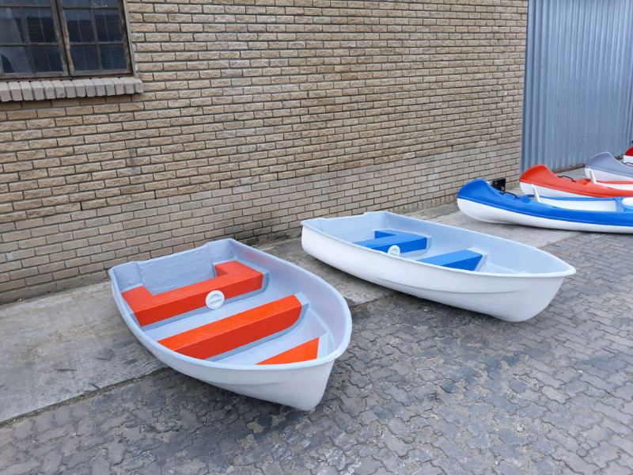

Post an ad like this for FREE!
- Date Listed 03/03/2018
- Location
George, Eden
- For Sale By Dealer

New 2.6m dinghy boats!! ● can take between 2 and 3 people ● bouyancy certificate ● comes with handles to carry ● can fit on a bakkie ● can take outboard motor (2hp-5hp) Can be couriered to any place in SA! Can be made in any color! 0728832387

